**SMART PARKING**

**Naan** Mudhalvan **Phase-2**

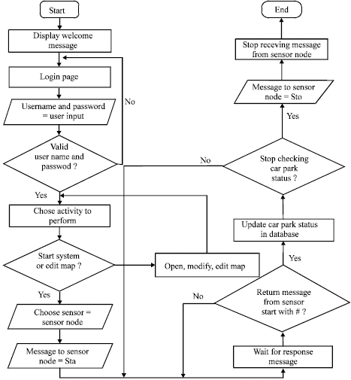FLOW CHART :

SMART PARKING DESIGN :

1. Hardware and Sensor Setup:Choose and install parking sensors (e.g., ultrasonic or magnetic sensors) in parking spaces.Develop or configure firmware for the sensors to detect occupancy and communicate data to a central server.
2. Communication Network:Set up a network for data transmission. For example, you can use Wi-Fi, LoRa, or cellular connectivity.Code the communication protocols on both the sensor and server sides.
3. Central Server:Create a central server using a programming language like Python, Node.js, or Java.Develop an API to receive and process data from sensors.Implement a database to store parking space occupancy data.
4. User Interface (Web and Mobile App):Develop a web application and/or mobile app for users to check parking availability and reserve spots.Use HTML, CSS, and JavaScript for web development and platform-specific languages (e.g., Java/Kotlin for Android, Swift for iOS) for mobile app development.
5. Payment Integration:Integrate payment gateways, such as Stripe or PayPal, into your web and mobile app.Code the payment processing logic and security measures.
6. Data Analysis and Predictive Algorithms:Implement algorithms to analyze parking data and predict availability. Machine learning can be useful here.Use libraries or frameworks (e.g., scikit-learn for Python) for machine learning if necessary.
7. Security:Implement robust security measures to protect user data and server-client communication.Use encryption and secure authentication methods.
8. Testing:Perform unit testing, integration testing, and load testing for the entire system.Fix any bugs or issues found during testing.
9. Compliance and Regulations:Ensure the project complies with local laws and data privacy regulations.Document and validate compliance in the code.10.
10. Maintenance and Support:Develop scripts and code for remote maintenance and sensor calibration.Implement error logging and reporting.
11. Launch and Promotion:Launch the system and promote it to potential users through marketing and awareness campaigns.
12. Data Analysis and Optimization:Continuously analyze data to optimize parking management and pricing.Adjust algorithms and code as needed.
13. Scaling and Expansion:Plan for future expansion and code the necessary infrastructure for scalability.

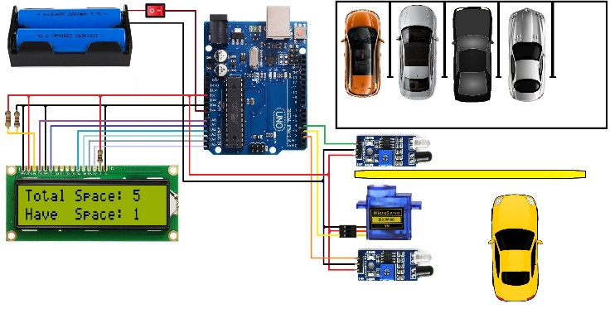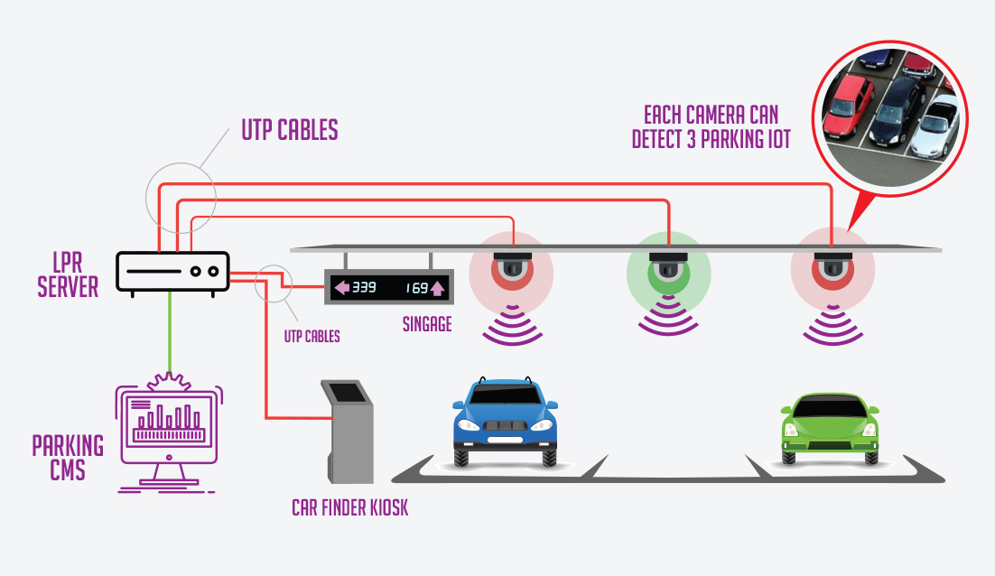

SUMMARY :

Smart parking refers to the use of technology and data-driven solutions to efficiently manage and optimize parking spaces. It aims to enhance the user experience by providing real-time information about parking availability, streamlining payment processes, and improving overall parking space management. This approach reduces congestion, saves time, and maximizes the utilization of parking resources.

TEAM MEMBERS :

1. REEGAN RUSOUL.L
2. RIYAZ KHAN.S
3. AROCKIA JAYARAJ.S
4. NOVA AROCKIA RAJ.V
5. SAKTHIVEL.N